Global Systems
An ecosystem, short for 'ecological system', includes all the living organisms existing together in a particular area.
These plants and animals within an area interact with each other and with the non-living elements of the area, such as climate, water, soil and so on.
An ecosystem can be very small, such as a puddle or an area under a large rock, or it can be vast, such as an ocean.
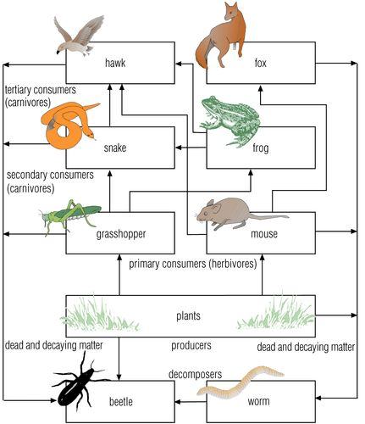
A sustainable ecosystem is one that is diverse and supports all of the living things in that ecosystem.
Biosphere is all of the ecosystems in the world added together.
In this part of the term we will look at some of the different systems that work together in world and see how some of them are changing.

Key words
Word | Meaning
Ecosystem

Sustainable ecosystem

Biosphere

Producers | Plants that make food for an ecosystem by photosynthesis.
Primary consumers (herbivores) | Animals that eat plants.
Secondary consumers (carnivores) | Animals that eat primary consumer animals.
Tertiary consumers (carnivores) | Animals that each primary and secondary consumer animals.

